1. Which are the 2 main API styles?
   1. REST
   2. Procedure Oriented
   3. Entity Oriented
   4. Graph
2. What is the shared responsability model?
   1. A model describing the responsability of the cloud and the customer with regards of security
   2. A requirement for the ISO 27001 standard
   3. A model describing the responsability within a development team
   4. A framework for finding out the optimal security approach
3. Which of the following represent types of load balancers?
   1. NAT
   2. HTTP
   3. DNS
   4. TCP/PPD
4. Related to user access and permissions for infrastructure security, confidentiality enforces
   1. usage of password vaults
   2. two factor authentication
   3. saving data only in private clouds
   4. encryption
5. Monitoring of the virtual host is useful to ensure:
   1. knowing your curent price to pay
   2. knowing when to scale (up/down, in/out)
   3. knowing the size of the database
   4. if provider respects contracts (SLA)
6. Which of the following characteristics is improved by designing and building applications in cloud enviroments?
   1. Control
   2. Scalability
   3. Availability
   4. Security
7. FaaS stands for
   1. Functions as a service
   2. Functionality as a service
   3. Frontend as a service
8. In a cloud environment the role of a load balancer is to:
   1. balance traffic across multiple targets
   2. A/B testing
   3. serve as a single point of entry
   4. monitor the health of target resources
9. Among the techniques for achieving high availability are:
   1. floating/elastic IP
   2. multi region
   3. real time operating system
   4. multi availability zones
10. What makes a system highly available?
    1. data
    2. software
    3. hardware
    4. network
11. Infrastructure security is concerned with
    1. cloud user
    2. database user
    3. operating system user
    4. application user
12. What of the following components are not managed by the cloud provider in a infrastructure as a Service model?
    1. Storage
    2. Network
    3. Operating system
    4. Application
    5. Data
13. Which are the two effective measures to improve infrastructure security?
    1. Implement OAuth 2.0
    2. MFA for the users
    3. MFA for the development team
    4. Reduce the attack surface as much as possible
14. How are the messages retrieved from queues in comparison to pub/sub systems?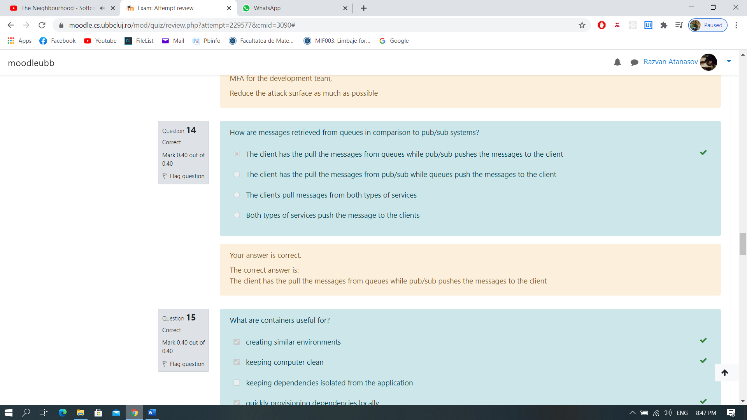
15. What are containers useful for?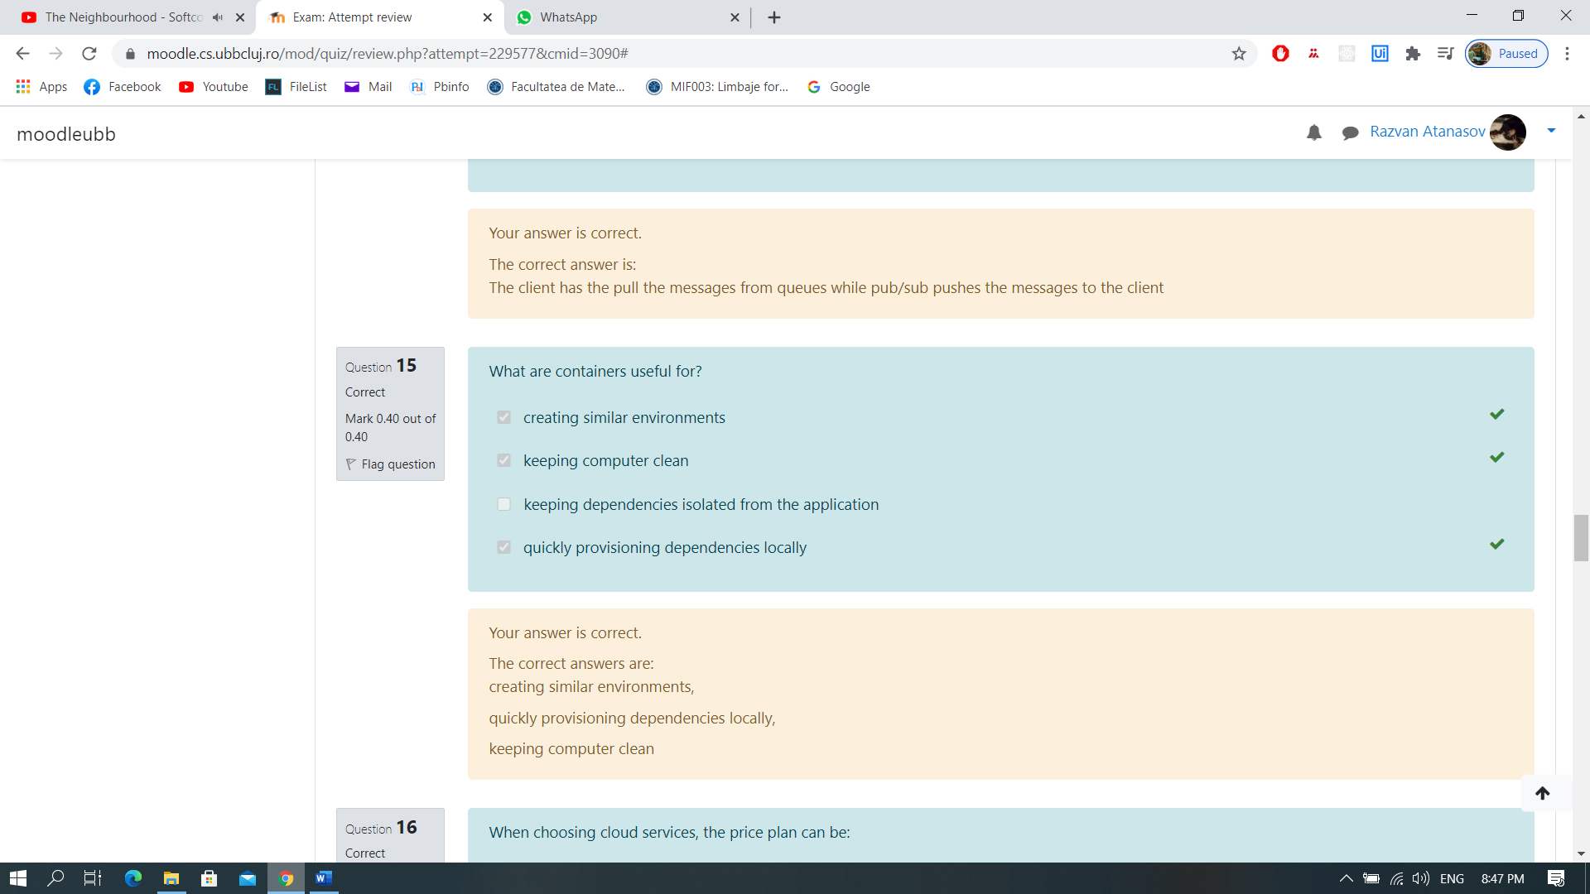
16. When choosing cloud services, the price plan can be: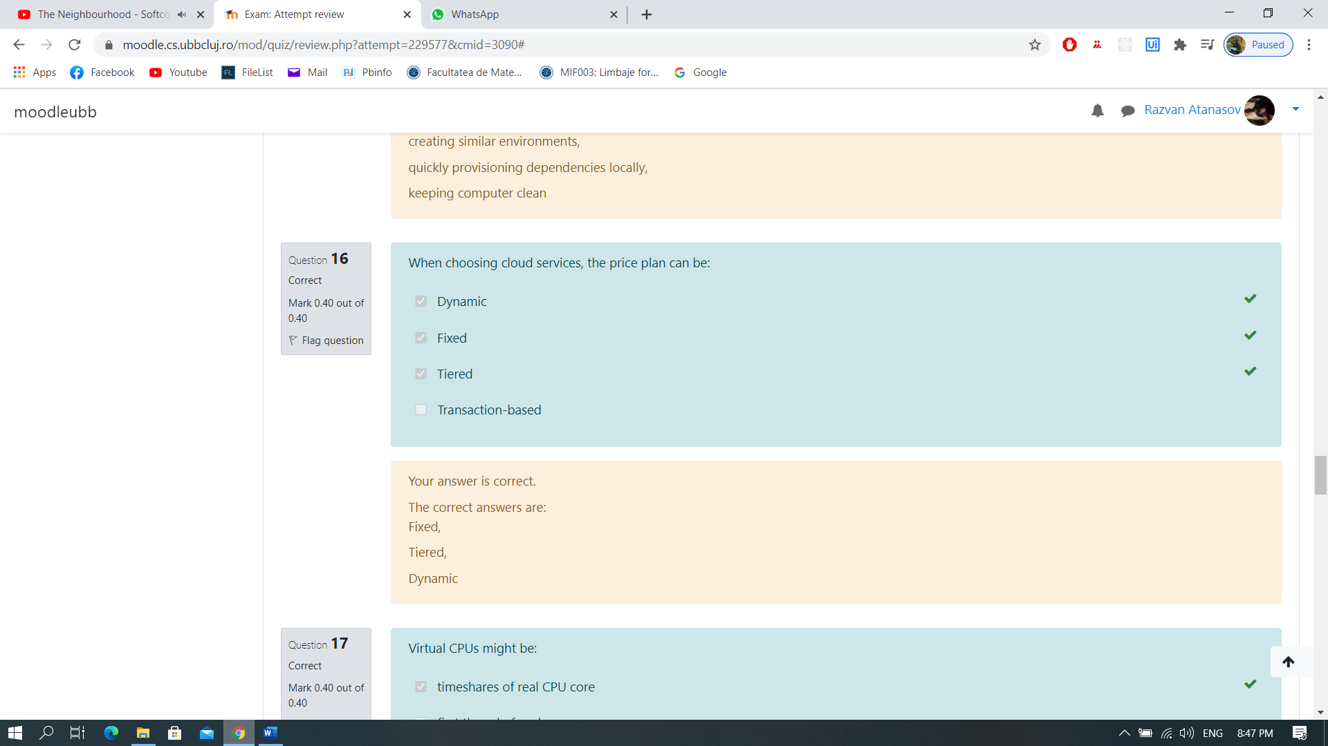
17. Virtual CPUs might be: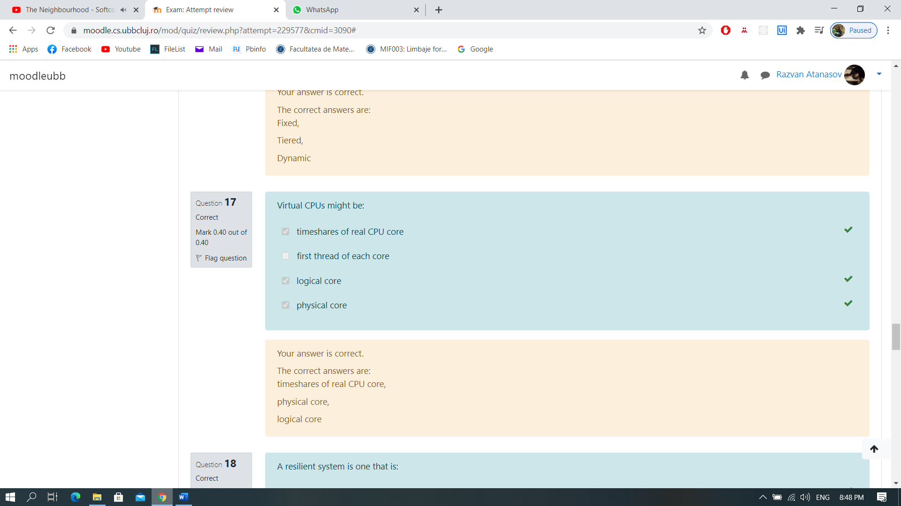
18. A resilient system is one that is: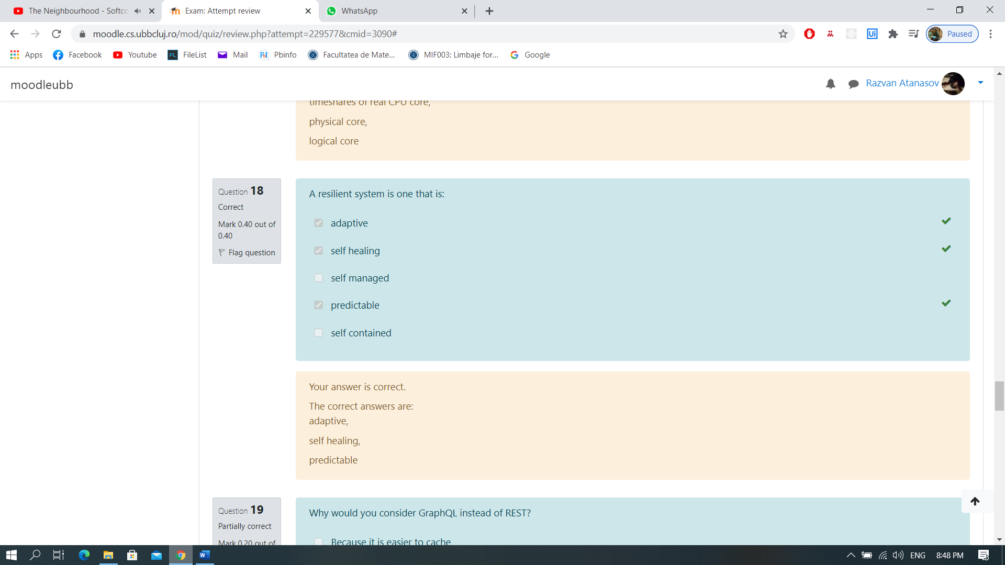
19. Why would you consider GraphQL instead of REST?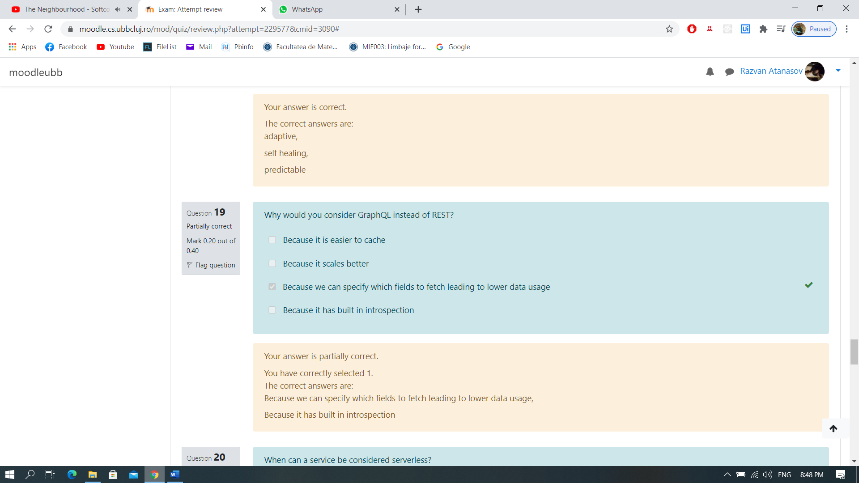
20. When can a service be considered serverless?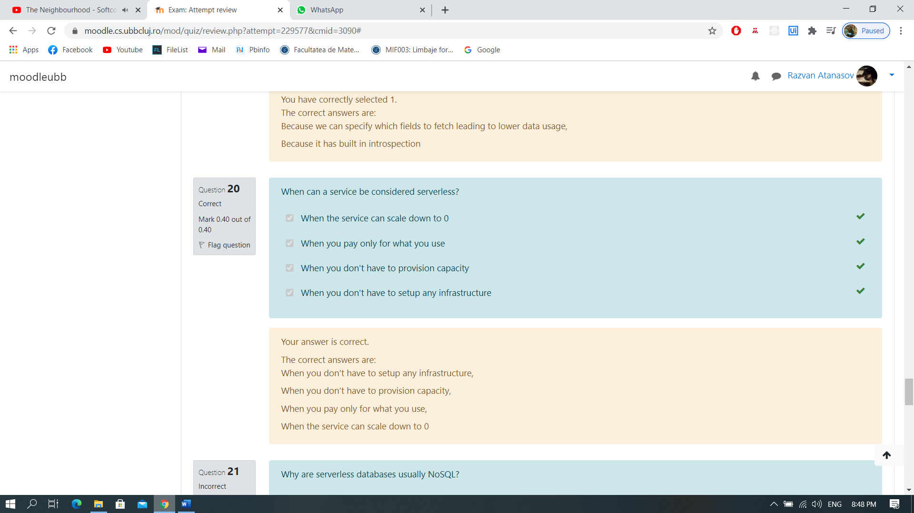
21. Why are serverless databases usually noSQL?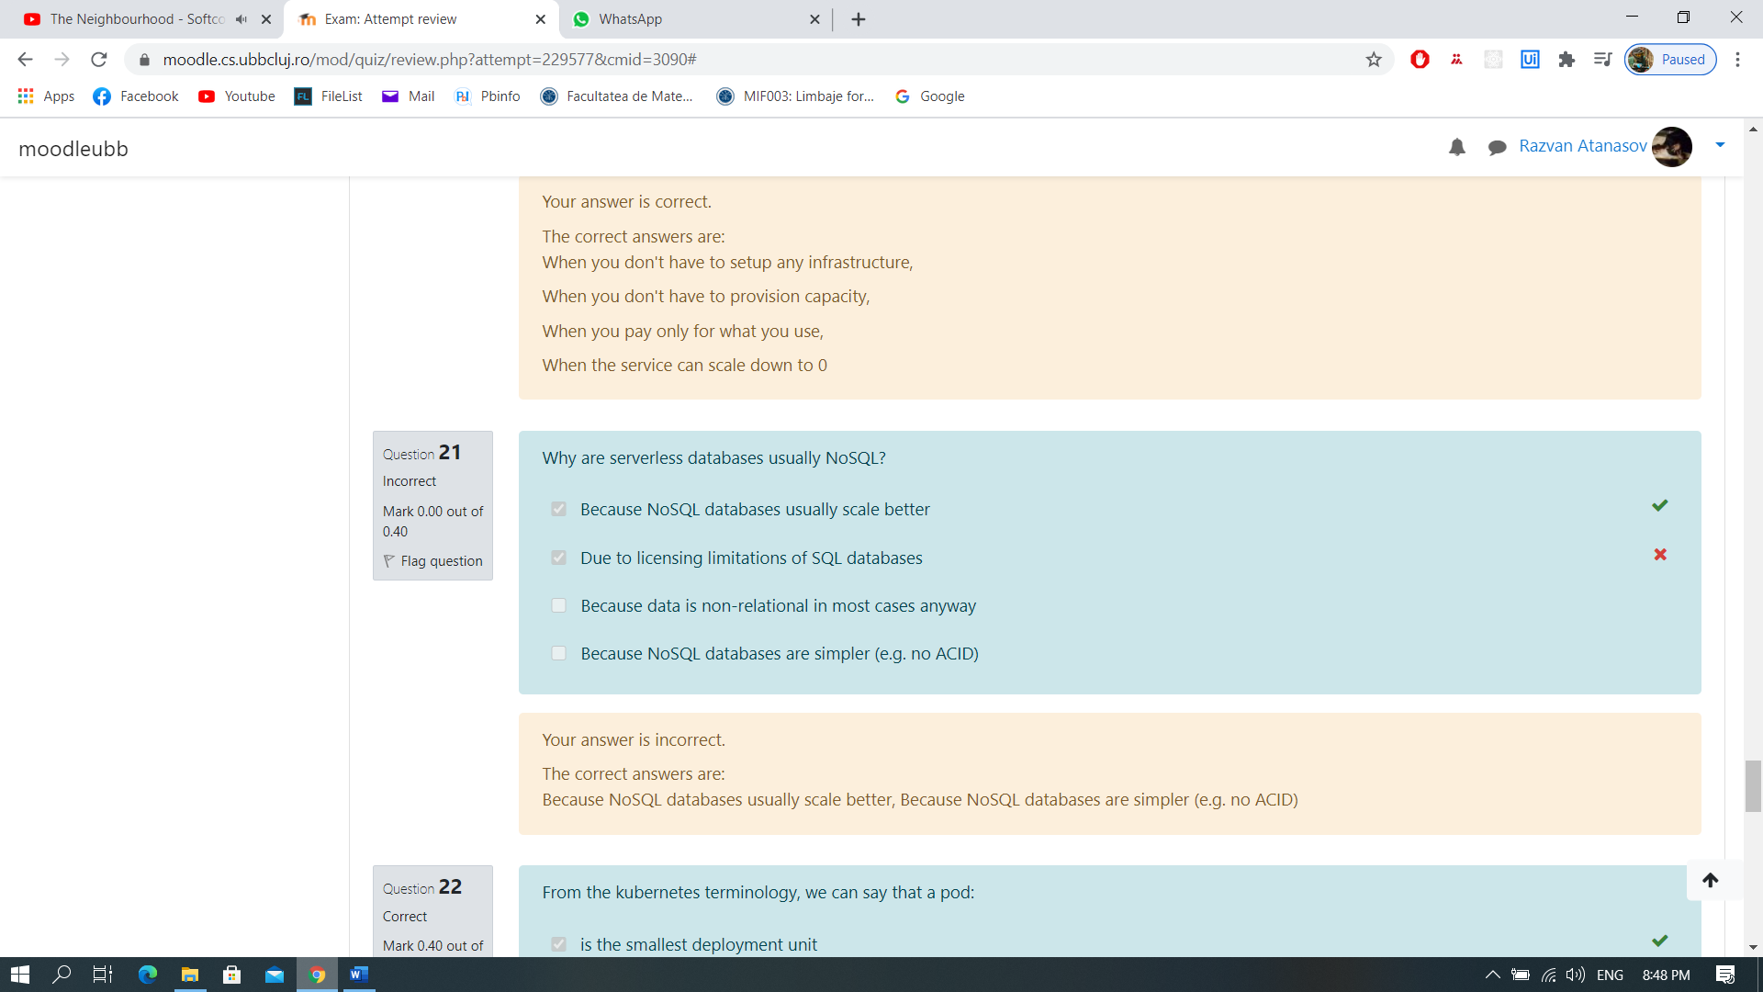
22. From the kubernetes terminology, we can say that a pod: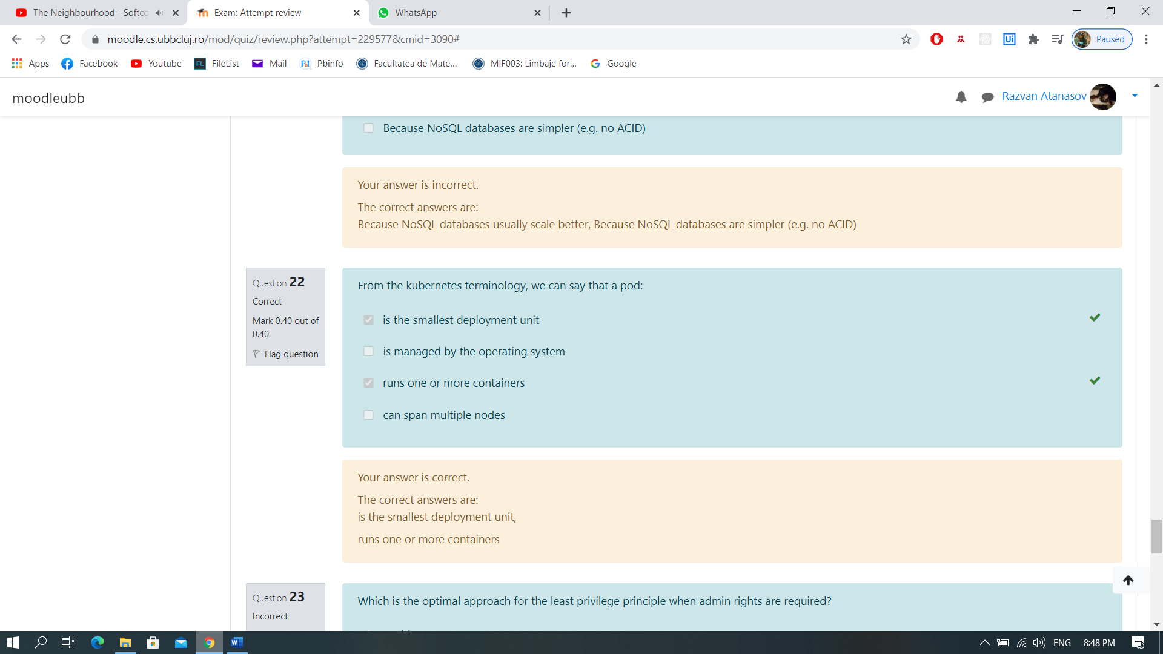
23. Which is the optimal approach for the least privilege principle when admin rights are required?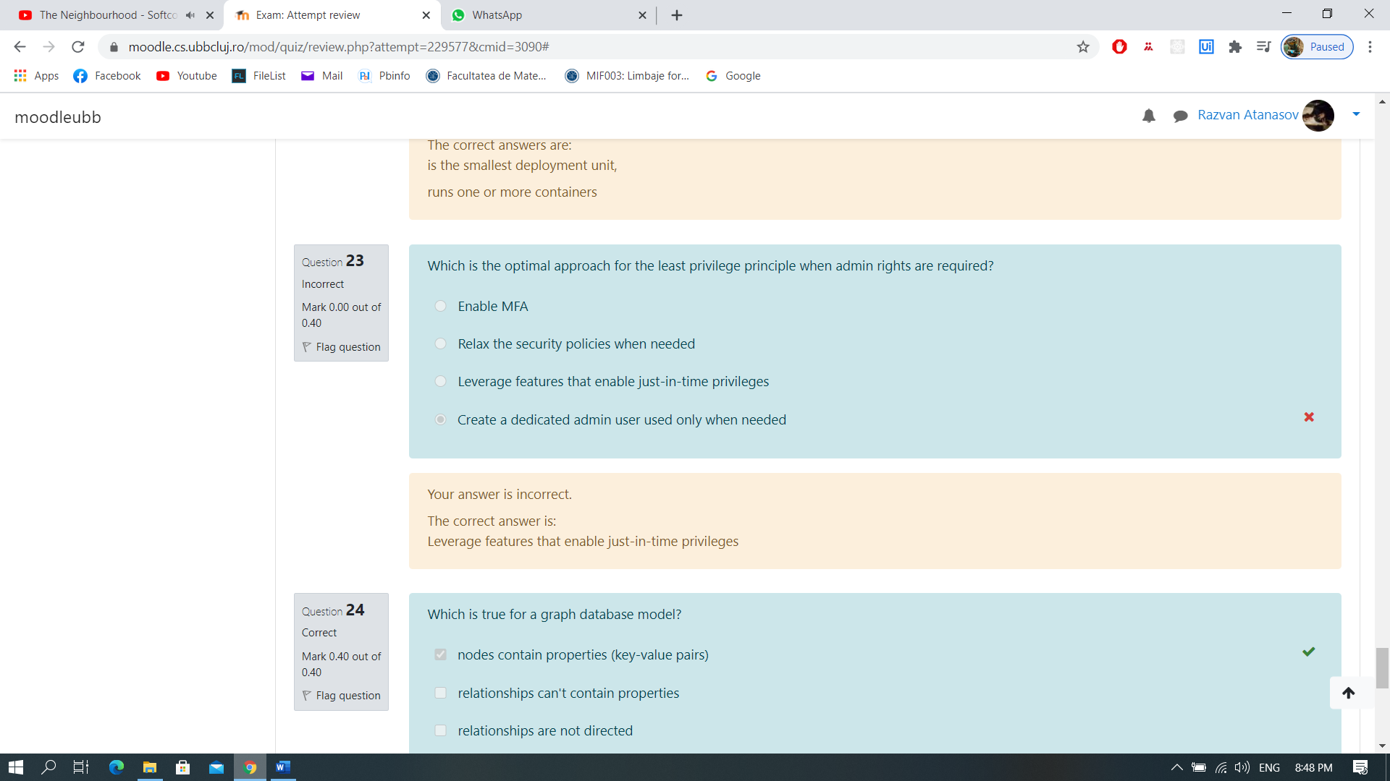
24. Which is true for a graph database model?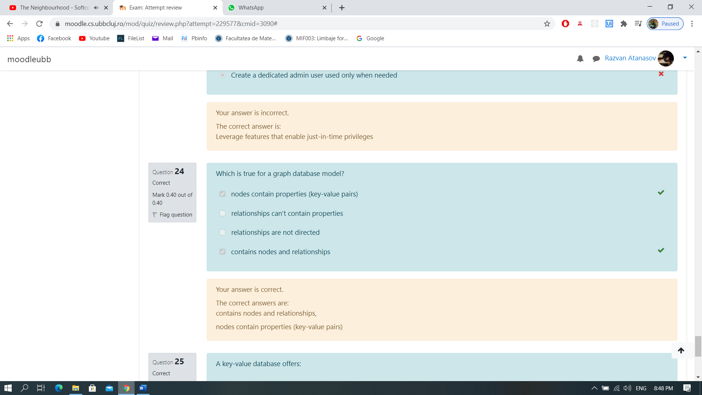
25. A key-value database offers: